## **Using Lambda to stop and start Amazon EC2 instances at regular intervals**

## 

1. Create a custom AWS Identity and Access Management (IAM) policy and IAM role for your Lambda function.

1. Create Lambda functions that stop and start your EC2 instances.

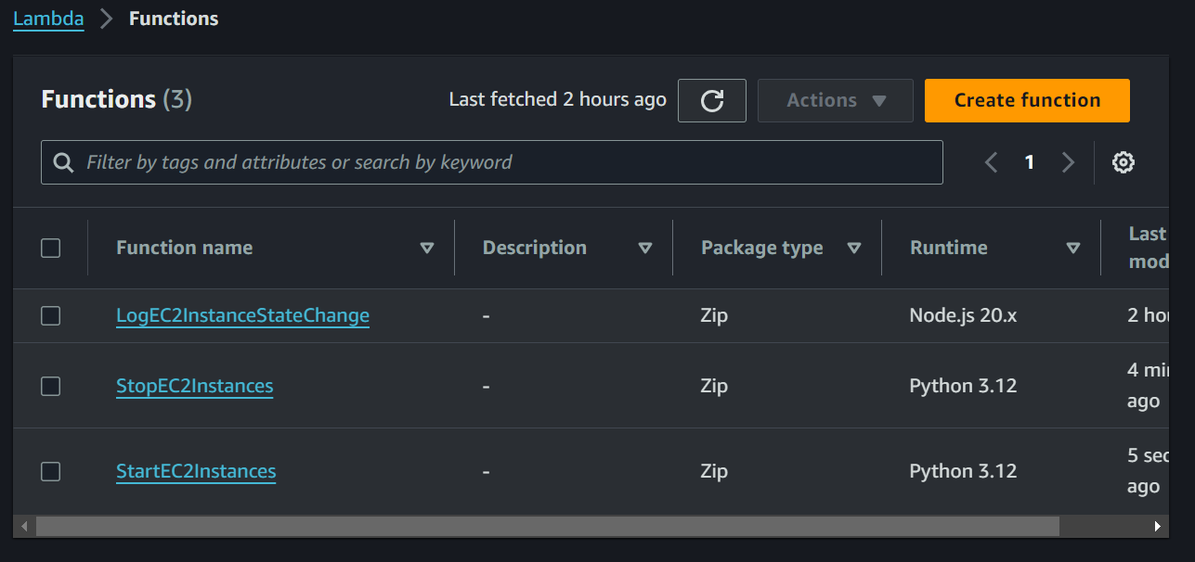

1. Test your Lambda functions.
   1. After testing the StopEC2instances function

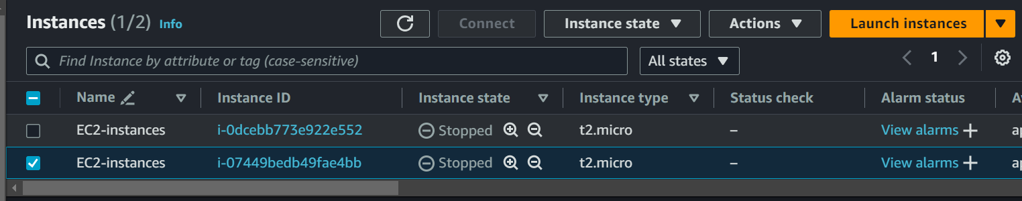

* 1. Return Response for lambda function

* 1. After testing the StartEC2instances function

1. Go to Cloudtrail and check the event history if the logs of startinstances and stopinstances are present

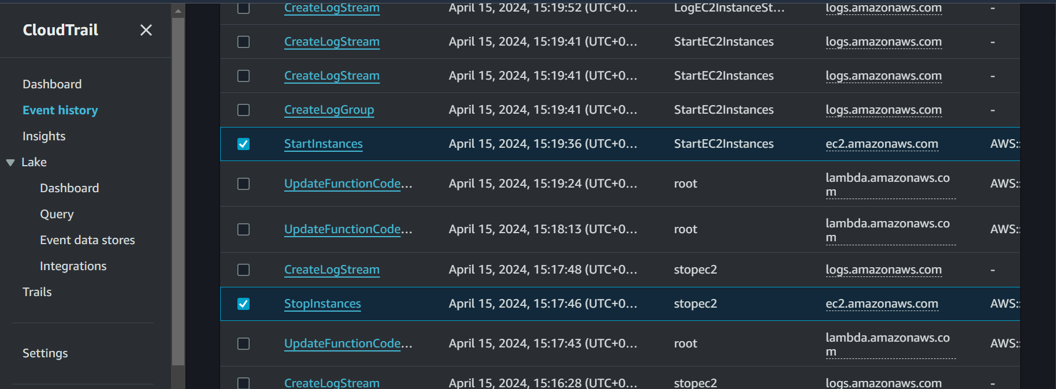

1. Now go to event bridge, create a schedular for stopinstances and select stopinstances lambda function.x

1. The instances will be stopped

1. Now, delete the stopinstances schedular, create another schedular for startinstances and select startinstances lambda function.

1. Now, the instances are started again

